**Exercise: Building a dashboard**

**Introduction**

You're part of the data analytics team at Adventure Works, responsible for transforming streams of raw data from around the globe about products, sales, and customers into a strategic tool to support business success. The company's CEO relies on you to provide insights that empower her to quickly and effectively understand the complex narrative of the company's performance. Microsoft Power BI's dashboarding capabilities are your answer to condensing an ocean of data into a few clear, digestible visuals. That's why, in this exercise, you'll practice creating an executive summary dashboard in Power BI for the CEO of Adventure Works.

**Case study**

In Power BI, a dashboard is a collection of visuals, reports, and other data that provides a consolidated view of business data, making it an essential tool for any executive. In preparation for building your dashboard, your manager gives you three separate reports: *Adventure Works Product Sales Report*, *Adventure Works Customer Report*, and *Adventure Works Order Report*. Each report contains specific visuals that tell a unique part of the business story. Your task is to gather the most important elements from these reports and bring them together to create the executive dashboard.

**Instructions**

Download the following Power BI report files to your local machine. Then, follow the prompts below to complete the exercise.

[Adventure Works Order Report](https://d3c33hcgiwev3.cloudfront.net/CA2Pxf7fQl2efHnI9SKI7A_ab43fe5a267f49c08c1303c3539b0ee1_Adventure-Works-Order-Report.pbix?Expires=1711843200&Signature=VNFcH~pq38eMoMcCJlyE6fPIW6Dk8WOU~JfuyrVzZ3l5Xc1LMMrUAGGJN42tJ2kFT~J8~-ry5I8O8MQlc29nnyr0zpgWEN6B6hQfbxcusC60IPCB5bAJDYccwl6uY3do6aKqyhQtCFizcEE99dQ-WcX2bqFp0qQh~cXyDdjgWTs_&Key-Pair-Id=APKAJLTNE6QMUY6HBC5A" \t "_blank)

[PBIX File](https://d3c33hcgiwev3.cloudfront.net/CA2Pxf7fQl2efHnI9SKI7A_ab43fe5a267f49c08c1303c3539b0ee1_Adventure-Works-Order-Report.pbix?Expires=1711843200&Signature=VNFcH~pq38eMoMcCJlyE6fPIW6Dk8WOU~JfuyrVzZ3l5Xc1LMMrUAGGJN42tJ2kFT~J8~-ry5I8O8MQlc29nnyr0zpgWEN6B6hQfbxcusC60IPCB5bAJDYccwl6uY3do6aKqyhQtCFizcEE99dQ-WcX2bqFp0qQh~cXyDdjgWTs_&Key-Pair-Id=APKAJLTNE6QMUY6HBC5A" \t "_blank)

[Adventure Works Product Sales Report](https://d3c33hcgiwev3.cloudfront.net/WnkOH8jiS1i9JmE8W0uGpw_6bc4c252618f43ab9971f046cf5580e1_Adventure-Works-Product-Sales-Report.pbix?Expires=1711843200&Signature=AcBkLKMMtzxWw8rfz89O7a6U1y1BgtrJEftdjyw~DqGh5DuEgZ8hZ5uPp9CZOfZRE8BRUyIUEQvcAq3ugnU0a2WNGL~sgsz6hz-hbIm~YJ-eip6R6AK9dHUiXY3vovUGyS8bw6ofpTPDmSiekdK6WqxwpV~jz~VyahD81hmISXA_&Key-Pair-Id=APKAJLTNE6QMUY6HBC5A" \t "_blank)

[PBIX File](https://d3c33hcgiwev3.cloudfront.net/WnkOH8jiS1i9JmE8W0uGpw_6bc4c252618f43ab9971f046cf5580e1_Adventure-Works-Product-Sales-Report.pbix?Expires=1711843200&Signature=AcBkLKMMtzxWw8rfz89O7a6U1y1BgtrJEftdjyw~DqGh5DuEgZ8hZ5uPp9CZOfZRE8BRUyIUEQvcAq3ugnU0a2WNGL~sgsz6hz-hbIm~YJ-eip6R6AK9dHUiXY3vovUGyS8bw6ofpTPDmSiekdK6WqxwpV~jz~VyahD81hmISXA_&Key-Pair-Id=APKAJLTNE6QMUY6HBC5A" \t "_blank)

[Adventure Works Customer Report](https://d3c33hcgiwev3.cloudfront.net/cKiCpwO0SXCyd09zBtr0dg_0580c31cc2ff45e08ce3b241149797e1_Adventure-Works-Customer-Report.pbix?Expires=1711843200&Signature=f~FY4Dwn7qSO2ajQNkzl46ox0k3IYbvqeIJ26RCfyhccbDOVfEEONBPjmHPXr~gmHdYOu0iMW-TFEAtwqQp-KlTM2abDfWktjtR8-LQFIQLfRGMltisPEi3477fzDTwjNoprhnqftxfO2wAx2DDX2TRDipFKNtfy7oybluoG8ug_&Key-Pair-Id=APKAJLTNE6QMUY6HBC5A" \t "_blank)

[PBIX File](https://d3c33hcgiwev3.cloudfront.net/cKiCpwO0SXCyd09zBtr0dg_0580c31cc2ff45e08ce3b241149797e1_Adventure-Works-Customer-Report.pbix?Expires=1711843200&Signature=f~FY4Dwn7qSO2ajQNkzl46ox0k3IYbvqeIJ26RCfyhccbDOVfEEONBPjmHPXr~gmHdYOu0iMW-TFEAtwqQp-KlTM2abDfWktjtR8-LQFIQLfRGMltisPEi3477fzDTwjNoprhnqftxfO2wAx2DDX2TRDipFKNtfy7oybluoG8ug_&Key-Pair-Id=APKAJLTNE6QMUY6HBC5A" \t "_blank)

**Step 1: Upload the pre-made reports to Power BI service**

1. Open a new tab in your web browser and navigate to the Power BI service website at [**https://app.powerbi.com/**](https://app.powerbi.com/).
2. Within the **Adventure Works** workspace, which you created in the previous activity, locate and select the **Upload** button on the top left of the screen.
3. From the dropdown menu, select **Browse**.
4. Select the first report you want to upload. **Note:** You can only upload one report at a time.
5. To start the uploading process, select **Open**.
6. Repeat steps 3 to 5 for each report.

**Step 2: Create a new dashboard**

1. In the **Navigation** view of **My Workspace**, locate and select the **+ New** button on the top left corner of the screen. This button serves as a quick action to create new BI assets.
2. A menu will appear with options such as **Report**, **Dashboard**, **Scorecard**, and so on. You're creating a dashboard for this step, so select **Dashboard** from the list.
3. A pop-up window titled **Create a dashboard** will appear. Type **Adventure Works Executive Summary** in the **Name** field.
4. Select **Create**.

**Note:** This action creates a new dashboard shell and redirects you to it. At this point, it's empty because you haven't added any content to it.

**Step 3: Pin live reports to the dashboard**

1. On the left side of your Power BI service screen, locate and select **Workspaces** > **My Workspace** again.
2. Find and select the *Adventure Works Product Sales Report* in the list of reports within the workspace. This opens the report for viewing and editing.
3. Locate and select the ellipsis (**…**) option on the top-right corner of the menu bar.
4. From the dropdown menu that appears, navigate to **Pin to a dashboard**. A window will appear, showing a preview of the page and a dropdown to select which dashboard to pin the page to.
5. Select the **Adventure Works Executive Summary** dashboard from the dropdown menu and then **Pin live**.
6. Repeat steps 1 to 5 for the visuals in the *Adventure Works Customer Report* and the *Adventure Works Order Report*. Each report will contribute important visuals to your dashboard, providing a comprehensive view of business performance.

**Step 4: Add Quick Insights**

1. Navigate to the **My Workspace** area of the Power BI service and locate the specific dataset you're interested in. Start with the *Adventure Works Product Sales Report*.
2. Select the ellipsis (**...**) next to the report name. Find and select **Quick Insights**. **Note:** This prompts Power BI to start an automated search for data insights. It can take a few minutes for Power BI to complete this analysis.
3. Once Power BI generates insights, it will present them as a list of visuals. As you review the results, you decide that the **Product Stock by Customer Feedback** visuals might be helpful to your CEO.
4. To pin the **Product Stock by Customer Feedback** visual to your dashboard, hover over the visual and select the **pin** icon in the top right corner.
5. A pop-up window will ask you to select a destination dashboard for the visual. Choose your **Adventure Works Executive Summary** dashboard from the dropdown list and select **Pin**. The **Product Stock by Customer Feedback** visual will now appear on your dashboard, ready to provide quick insight at a glance.
6. Repeat steps 1 to 5 for the *Adventure Works Order Report* and *Adventure Works Customer Report* datasets.

**Conclusion**

In this exercise, you learned how to use and refine various raw data sources into an executive summary dashboard for the Adventure Works CEO. Converting raw data into dynamic, intuitive dashboards full of quick insights is a vital skill that can help guide critical business decisio

**Exemplar: Building a dashboard**

**Introduction**

The *Building a dashboard* exercise challenged you with creating an executive summary dashboard for Adventure Works’ CEO. The task required transforming global data about products, sales, and customers into an insightful, intuitive tool for decision-making—a Power BI dashboard.

More specifically, your tasks were to:

* Upload pre-made reports to the Power BI service, providing you with the data you need for your dashboard.
* Create a new dashboard titled **Adventure Works Executive Summary**, giving the CEO a centralized, interactive interface for viewing and understanding the company's data.
* Pin live reports from the three reports to the dashboard, ensuring dynamic, interactive data is readily available to the CEO.
* Add **Quick Insights** to your dashboard, leveraging Power BI's automated analysis features to uncover hidden trends and patterns in the data.

This reading provides you with an exemplar guide that you can use to compare your solution.

**Building a dashboard**

In preparation for the exercise, you were asked to download the Power BI report files (*Adventure Works Product Sales Report*, *Adventure Works Order Report,* and *Adventure Works Customer Report*) to your local machine and then follow the prompts that below.

**Step 1: Upload the pre-made reports to Power BI Service**

1. Open a new tab in your web browser and navigate to the Power BI service website at [**https://app.powerbi.com/**](https://app.powerbi.com/). If you're not logged in, enter your Microsoft account credentials associated with Power BI.
2. Once logged in, find **My Workspace** on the left sidebar. Select it to enter your workspace, your personal area to create and manage your Power BI content.

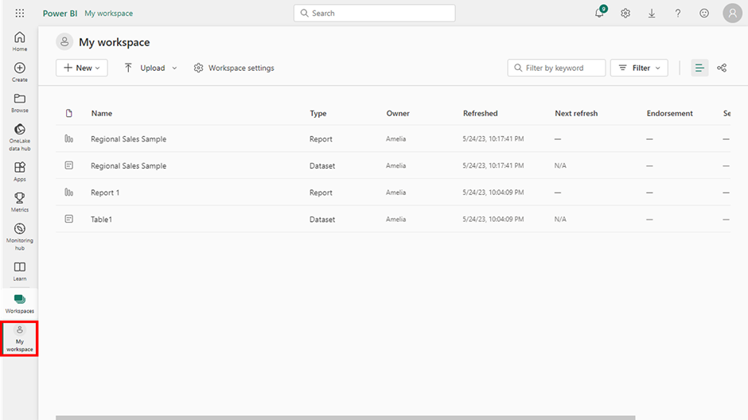

3. Within **My Workspace**, locate and select the **Upload** button on the top left of the screen. This will open a dropdown menu with options to create different types of content to upload.

4. From the dropdown menu, select **Browse**. This will open a file explorer window.

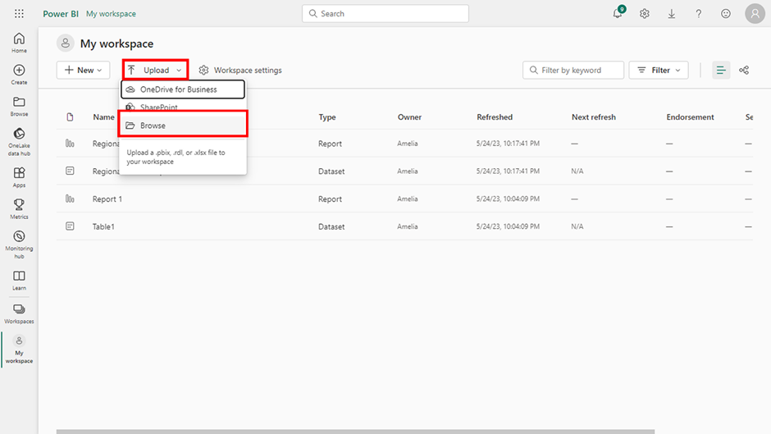

5. In the file explorer window, navigate to where you saved your downloaded reports. Select the first report you want to upload and then **Open** to start the uploading process.

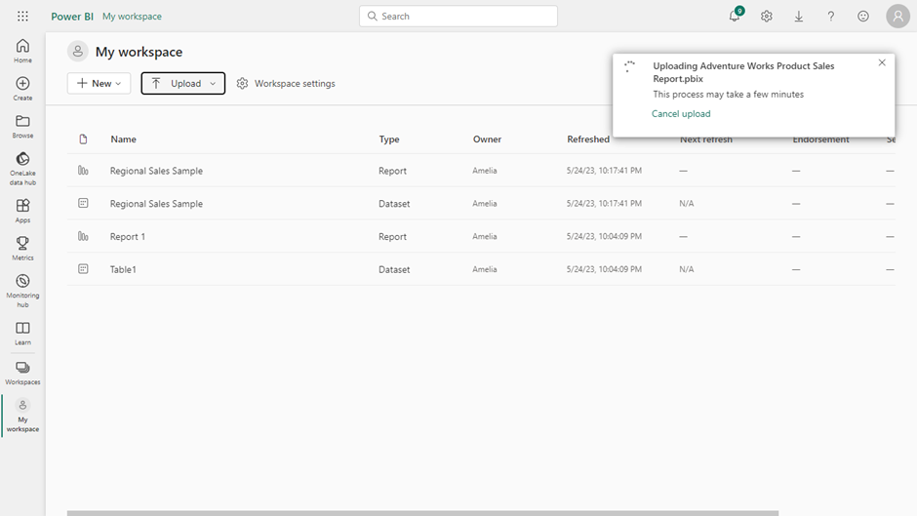

6. Repeat steps 3 to 5 for each report.

**Step 2: Create a new dashboard**

1. In the **Navigation** view of **My Workspace**, locate and select the **+ New** button on the top left corner of the screen. This button serves as a quick action to create new BI assets.
2. A menu will appear with options such as **Report**, **Dashboard**, **Scorecard**, and so on. You're creating a dashboard for this step, so select **Dashboard** from the list.

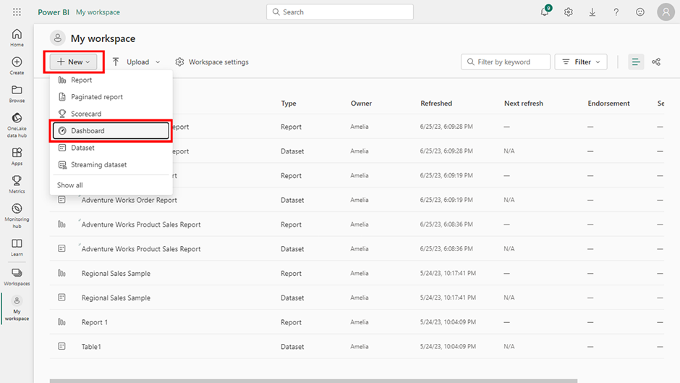

3. A pop-up window titled **Create a dashboard** will appear. It has a single field: **Dashboard Name**. The name you give should represent what the dashboard contains. This name will appear in lists and the dashboard header, so make it descriptive. Type **Adventure Works Executive Summary** in the **Name** field.

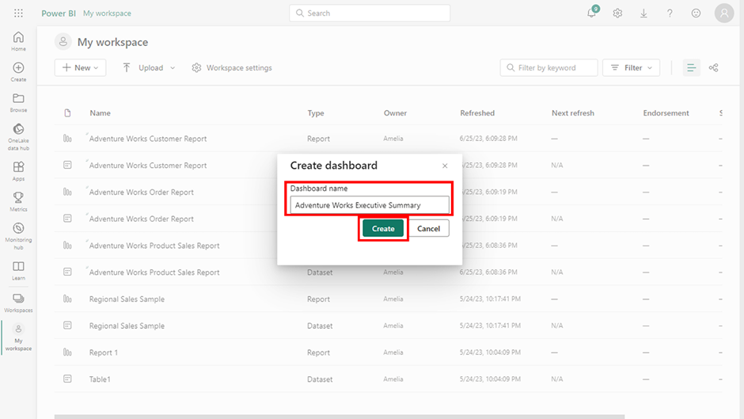

4. Select **Create**.

**Note:** This action creates a new dashboard shell and redirects you to it. At this point, it's empty because you haven't added any content to it.

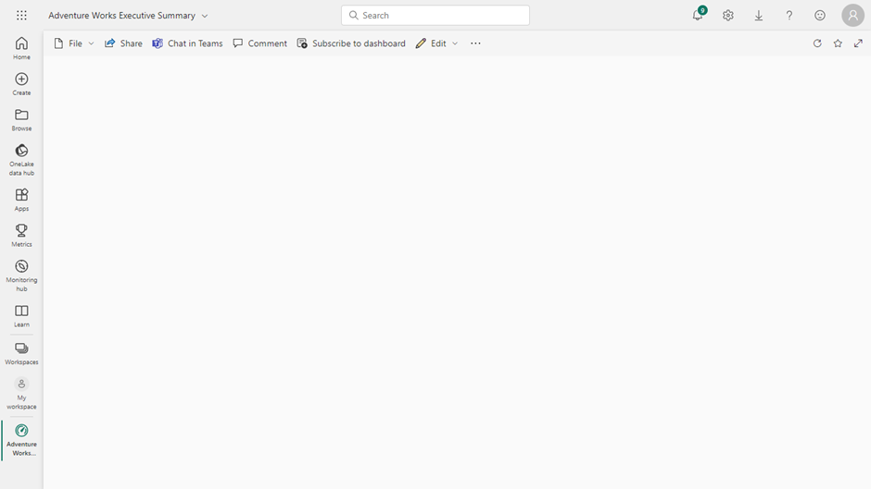

**Step 3: Pin live reports to the dashboard**

1. On the left side of your Power BI service screen, locate and select **Workspaces** > **My Workspace** again.

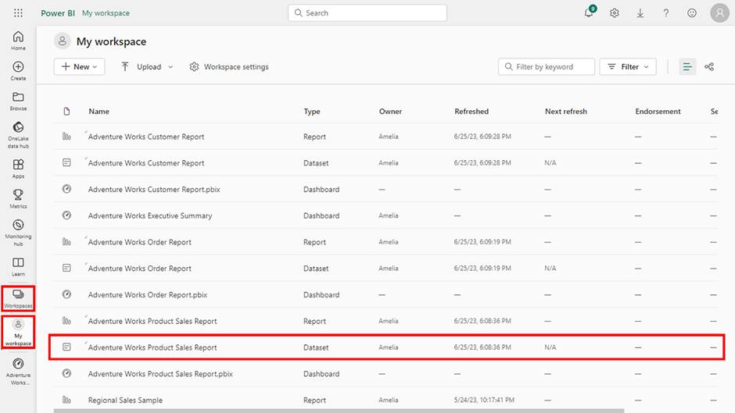

2. Find and select the **Adventure Works Product Sales Report** in the list of reports within the workspace. This opens the report for viewing and editing.

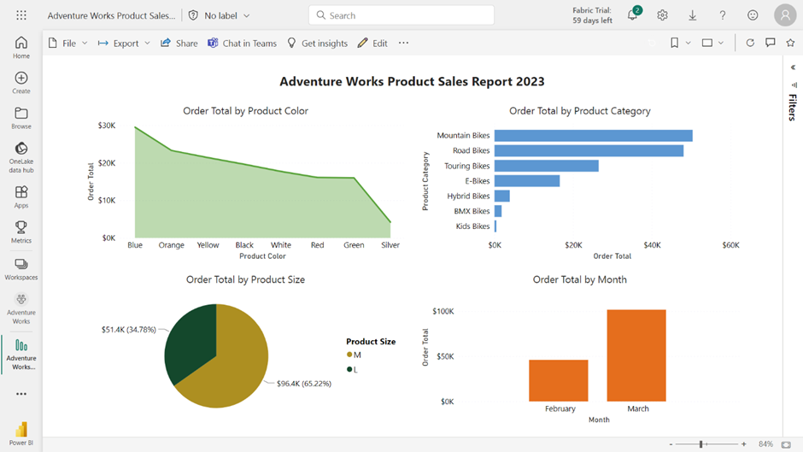

3. Locate and select the ellipsis (**…**) option on the top-right corner of the menu bar.

4. From the dropdown menu that appears, navigate to **Pin to a dashboard**. A window will appear, showing a preview of the page and a dropdown to select which dashboard to pin the page to.

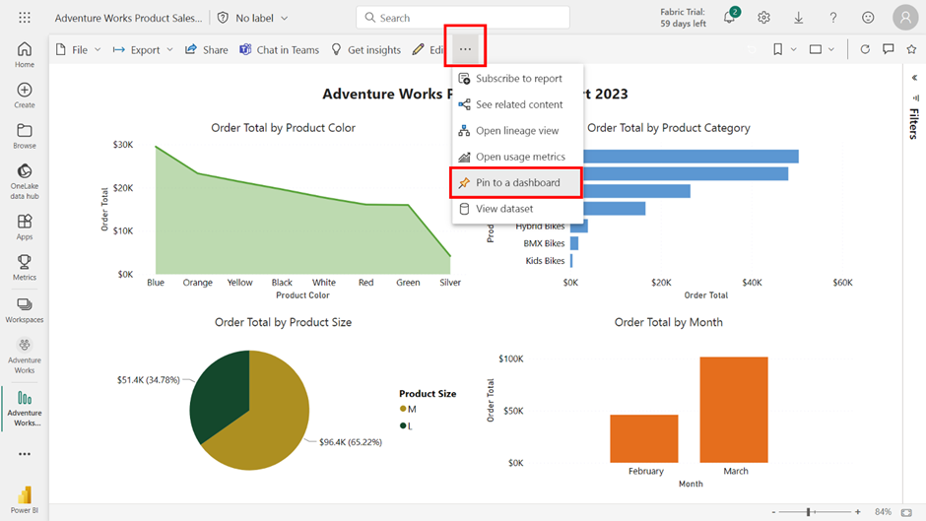

5. Select the **Adventure Works Executive Summary** dashboard from the dropdown menu and then **Pin live**.

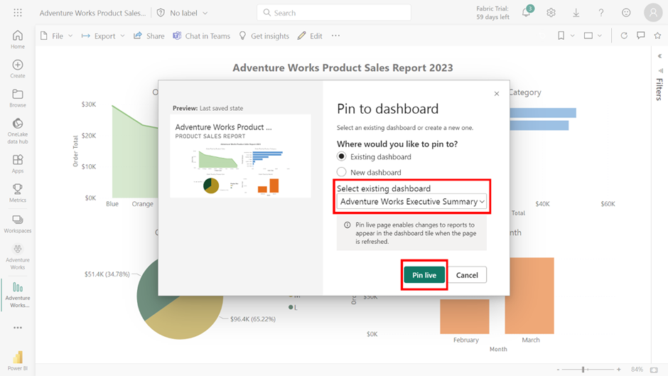

6. Repeat steps 1 to 5 for the visuals in the **Adventure Works Customer Report** and the **Adventure Works Order Report**. Each report will contribute important visuals to your dashboard, providing a comprehensive view of business performance.

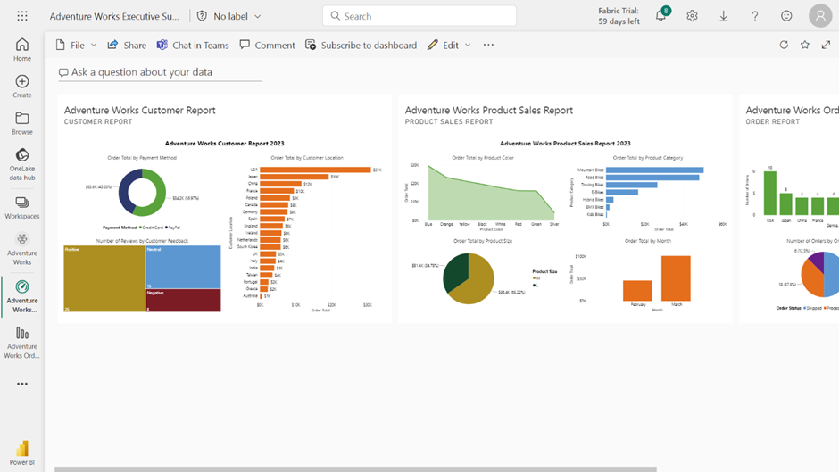

**Step 4: Add Quick Insights**

1. Navigate to **My Workspace** area of the Power BI service and locate the specific dataset you're interested in. This will depend on which report's insights you're attempting to generate. In this scenario, start with the **Adventure Works Product Sales Report.**
2. Select the ellipsis (**...**) next to the report name. A context menu with several options will pop up. These options allow you to perform various actions related to the dataset. In this list, find and click on **Get quick Insights**.

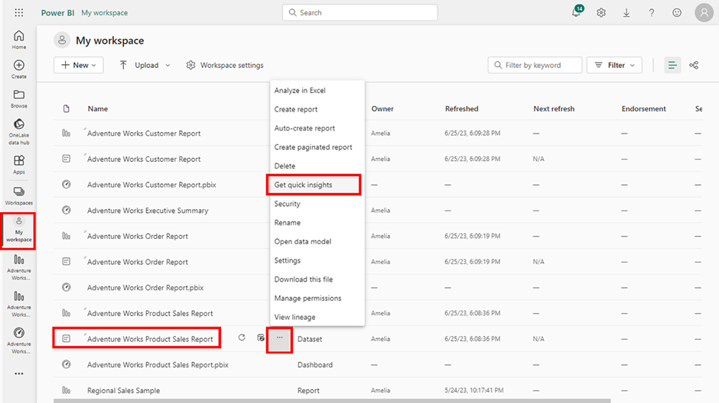

**Note:** This prompts Power BI to start an automated search for data insights. This functionality leverages machine learning algorithms to detect patterns, trends, and anomalies in your data that might not be readily apparent. It can take a few minutes for Power BI to complete this analysis, especially if your dataset is large or complex. Keep in mind that the effectiveness of Quick Insights depends on the nature and quality of your data, so it may not always produce useful results.

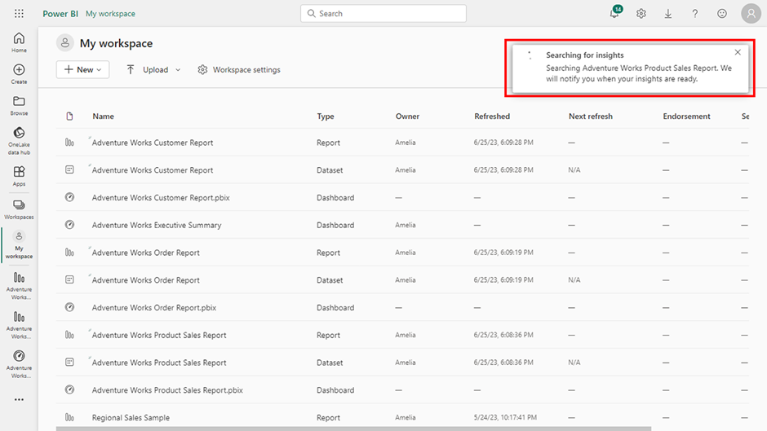

3. Once Power BI generates insights, it will present them as a list of visuals. As you review the results, you decide that the **Product Stock by Customer Feedback** visuals might be helpful to your CEO.

4. To pin the **Product Stock by Customer Feedback** visual to your dashboard, hover over the visual and select the **pin** icon in the top right corner.

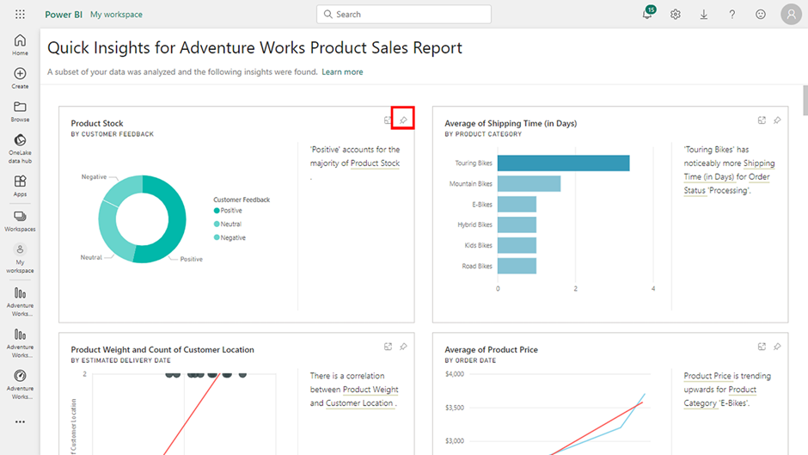

5. A pop-up window will ask you to select a destination dashboard for the visual. Choose your **Adventure Works Executive Summary** dashboard from the dropdown list and select **Pin**. The Product Stock by Customer Feedback visual will now appear on your dashboard, ready to provide quick insight at a glance.

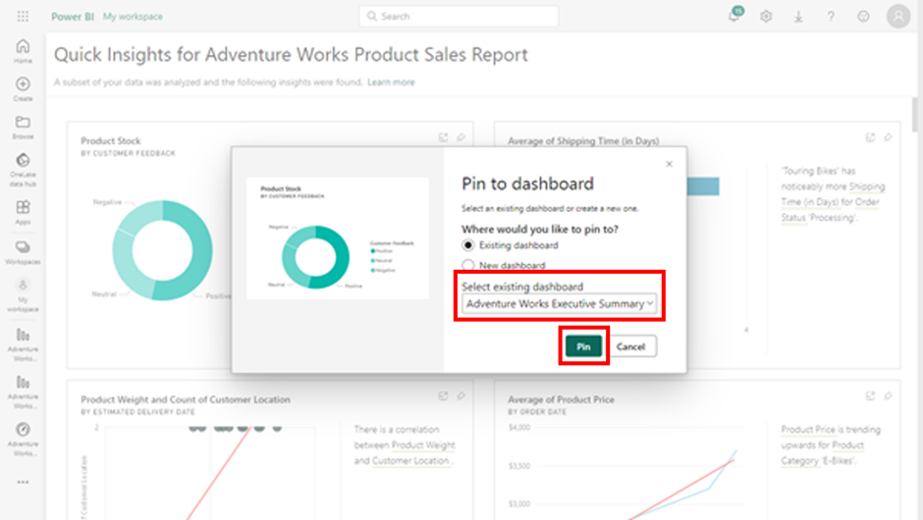

6. Repeat steps 1 to 5 for the **Adventure Works Order Report** and **Adventure WorksCustomer Report** datasets.

7. This is what the final **Adventure Works Executive Summary** looks like.

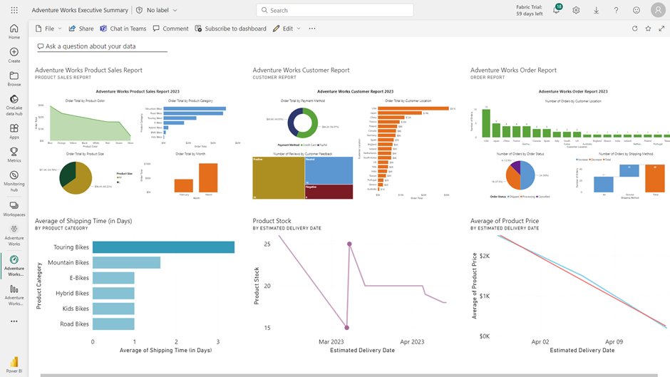

**Conclusion**

As you complete the exercise, take pride in the intuitive Power BI dashboard you've created, which may be similar to the output below. In the real-world scenario used in this exercise, the CEO at Adventure Works’ can use this executive summary dashboard to understand the company's performance at a glance, making data-driven decisions confidently and promptly. Mastering build Power BI dashboards adds great value to your growing data analytics skillset.

Mark as completed

Like

Dislike

Report an issue